Discrete Cosine Transform (Algorithm and Program)

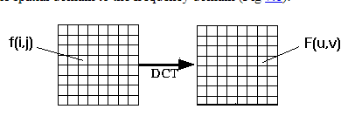

**Image Compression :** Image is stored or transmitted with having pixel value. It can be compressed by reducing the value its every pixel contains. Image compression is basically of two types :  
**1.** Lossless compression : In this type of compression, after recovering image is exactly become same as that was before applying compression techniques and so, its quality didn’t gets reduced.  
**2.** Lossy compression : In this type of compression, after recovering we can’t get exactly as older data and that’s why the quality of image gets significantly reduced. But this type of compression results in very high compression of image data and is very useful in transmitting image over network.

**Discrete Cosine Transform** is used in lossy image compression because it has very strong energy compaction, i.e., its large amount of information is stored in very low frequency component of a signal and rest other frequency having very small data which can be stored by using very less number of bits (usually, at most 2 or 3 bit).  
To perform DCT Transformation on an image, first we have to fetch image file information (pixel value in term of integer having range 0 – 255) which we divides in block of 8 X 8 matrix and then we apply discrete cosine transform on that block of data.

After applying discrete cosine transform, we will see that its more than 90% data will be in lower frequency component. For simplicity, we took a matrix of size 8 X 8 having all value as 255 (considering image to be completely white) and we are going to perform 2-D discrete cosine transform on that to observe the output

he DCT-II is:

Where: 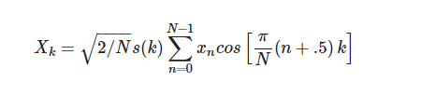

* X is the DCT output.
* x is the input.
* k is the index of the output coefficient being calculated, from 0 to N−1.
* N is the number of elements being transformed.
* s is a scaling function, s(y)=1 except s(0)=√0.5

The DCT transforms input xx to output XX. Both have the same number, NN, of elements.

**What does the DCT do?**

The DCT transforms an input signal from the time domain into the frequency domain.

This compacts the energy of the signal, mostly into the low-frequency bins.

The DCT is used as a building block for many kinds of lossy compression for audio, video, and still images.

An over-simplified compressor:

* Take an input signal.
* Apply the DCT.
* Throw away some of the information. ("quantize" the DCT coefficients)
* Losslessly compress the coefficients.
* The compressed data should be smaller than losslessly compressing the original signal.

**What is the DCT output?**

The DCT transforms an input signal into a combination of cosine waves.

The first DCT coefficient (X0X0) is sometimes called the "DC component" of the signal (DC as in direct current) because it's proportional to the average of all the input samples.

Each output coefficient corresponds to a DCT basis function. These functions are cosine waves of increasing frequencies.

If you multiply each basis function by its corresponding coefficient, their sum will be a reconstruction of the original input. This process is called the Inverse DCT and we'll cover it later.

The Discrete Fourier Transform (DFT) returns complex numbers. The DCT is equivalent to the real part of the DFT output.

The rest of this article deals specifically with an eight-point DCT-II, which is what JPEG compression is built on top of. Here is what the eight basis functions look like:

## Inverse DCT

The inverse of the DCT-II is the DCT-III. Its coefficient matrix is the transpose (rows become columns) of the DCT-II matrix. Or, if you prefer, the forward and inverse transforms are:

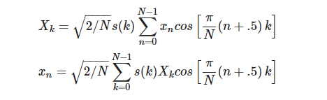

[Practical Fast 1-D DCT Algorithms with 11 Multiplications](http://www3.matapp.unimib.it/corsi-2007-2008/matematica/istituzioni-di-analisi-numerica/jpeg/papers/11-multiplications.pdf) is the LLM paper: it reviews several previous algorithms and gives a newer and more compact one. It was published in 1989.

[A Fast Computational Algorithm for the Discrete Cosine Transform](http://www.eit.lth.se/fileadmin/eit/courses/eit085f/Chen_A_Fast_Computational_Algorithm_for_the_Discrete_Cosine_Transform_Com_1977.pdf) is from 1977, and has an awesome block diagram of 4-point through 32-point DCTs on the last page.

* World record is 11 multiplies and 29 adds. (C. Loeffler, A. Ligtenberg and G. Moschytz, "Practical Fast 1-D DCT Algorithms with 11 Multiplications", Proc. Int'l. Conf. on Acoustics, Speech, and Signal Processing 1989 (ICASSP `89), pp. 988-991)

<https://ieeexplore.ieee.org/document/1163351>

<https://users.cs.cf.ac.uk/Dave.Marshall/Multimedia/node231.html>

